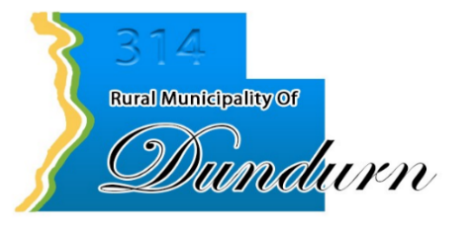

EMPLOYMENT OPPORTUNITY
Equipment Operator
The Rural Municipality of Dundurn No. 314 is accepting applications for an Equipment Operator to join our Public Works team for the remainder of the 2026 season.
This position is initially seasonal, with the opportunity to extend into a full-time permanent position based on performance, operational needs, and suitability for the role.
Position Responsibilities
The successful applicant will assist with the construction and maintenance of municipal roads and infrastructure. Duties may include:
- Operating graders, loaders, tractors, trucks, and other municipal equipment;
- Road grading, shaping, gravel spreading, and general road maintenance;
- Assisting with road construction and rehabilitation projects;
- Culvert installation and drainage maintenance;
- Mowing and other seasonal maintenance activities;
- Performing daily equipment inspections and basic preventative maintenance;
- Completing general labour and other Public Works duties as required; and
- Working safely and effectively as part of the RM's Public Works team.
Qualifications
The ideal candidate will:
- Have experience operating heavy equipment, particularly motor graders, loaders, and/or heavy trucks;
- Possess a valid driver's licence. A Class 1A licence is considered an asset;
- Have experience with municipal road construction and maintenance, agriculture, earthmoving, or a related field;
- Be mechanically inclined and capable of performing basic equipment inspections and maintenance;
- Be able to work independently and as part of a team;
- Demonstrate reliability, good judgment, and a strong commitment to workplace safety; and
- Be willing to work additional hours when required due to construction schedules, weather conditions, or operational needs.
Term of Employment
The position will begin as soon as possible and continue for the remainder of the 2026 construction and maintenance season.
There is an opportunity for the successful candidate to transition into full-time, year-round employment based on demonstrated performance and the ongoing needs of the municipality.
Compensation
Wages and other applicable terms of employment will be in accordance with the current Collective Bargaining Agreement.
How to Apply
Interested applicants are invited to submit a resume outlining their qualifications and equipment-operating experience to:
G. Craig Baird
Chief Administrative Officer
Rural Municipality of Dundurn No. 314
Email: rm314@dundurnrm.ca
The position will remain open until a suitable candidate is found.
We thank all applicants for their interest; however, only those selected for an interview will be contacted.

